**Autumn Newsletter 2020**

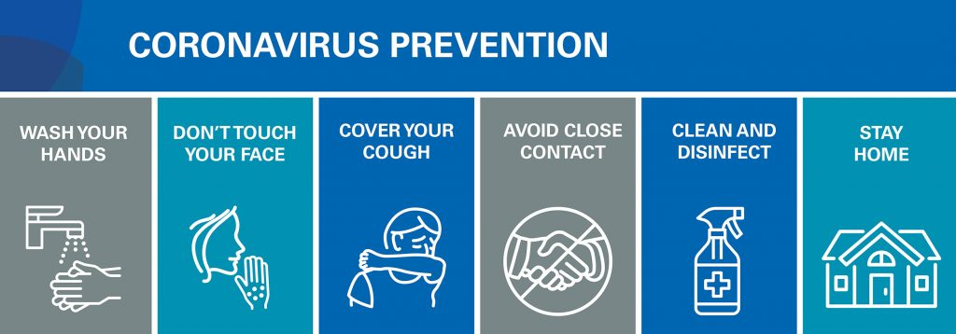

**Face Masks/Coverings:**

Please wear a face mask/face covering when entering the building. If you have an appointment we can provide you with a face mask. This is for your safety as well as others. We apologise for any delay in dealing with you. Due to the Covid19 safety measures we have to take, things can take a little longer than they used to!

You can help by attending the surgery to collect medication late morning or lunchtime. Early mornings can be chaotic. Do not make unnecessary trips to the surgery. Order your repeats in one batch etc. Allow plenty of time when collecting medication.

We are all trying our best during what is a very taxing and worrying time of us all. We need to keep our staff safe so we can be open and ready to help you.

Please note: The surgery **cannot** issue face covering exemption cards

**Flu clinics:**

Due to Covid19 we cannot hold our usual ‘walk in’ Saturday clinic. If you are eligible for an influenza vaccination **you will need to book an appointment**. We have received our first delivery of flu vaccinations. If you have given consent to be contacted via email or SMS texts we will have contacted you. If you would like to give consent to being contacted via email and/or SMS text message please let reception know.

**When attending the surgery for a flu vaccination:**

1. Please do not arrive too early for your appointment
2. Wear short sleeves
3. No unnecessary items should be brought in to the surgery with you
4. Use the toilet at home before attending the surgery
5. Wear a face covering or mask
6. Use hand gel before entering the building
7. Wait outside by the front door (there will be clear signage to show where to wait)
8. Keep 2 metres away from any other patients waiting

During some of the flu clinics we will be administering the vaccination in the lobby area. The idea being that the patient will enter by the front door facing the steps and exit using the front door into the car park. Only one patient will be in the lobby at one time. Patients waiting outside should keep 2 metres away from each other and please bear in mind the weather conditions. That’s one of the reasons we ask that you don’t arrive too early for your appointment, the other reason is that we have limited space in the surgery car park.

You may also be collected from the car park and taken to the Nurses Treatment room for your flu vaccination.

If you are eligible you may also be offered the shingles or pneumonia vaccination at the same time.

Not sure if you are eligible? Look at the NHS website for full details: https://www.nhs.uk/conditions/vaccinations/who-should-have-flu-vaccine/

Nasal Fluenz vaccinations for children (2-10 years of age) are already in stock and clinics to administer these will be set up soon.

**What is flu? Isn’t it just a heavy cold?**

Flu occurs every year, usually in the winter, which is why it’s sometimes called seasonal flu. It’s a highly infectious disease with symptoms that come on very quickly.

Colds are much less serious and usually start gradually with a stuffy or runny nose and a sore throat. A bad bout of flu can be much worse than a heavy cold.

The most common symptoms of flu are fever, chills, headache, aches and pains in the joints and muscles, and extreme tiredness. Healthy individuals usually recover within two to seven days, but for some the disease can lead to hospitalisation, permanent disability or even death.

**Who should get the flu vaccine?**

Flu can affect anyone but if you have a long-term health condition the effects of flu can make it worse even if the condition is well managed and you normally feel well.

This year the flu vaccine is being offered on the NHS to:

* adults 65 and over
* **Later in the year, the flu vaccine may be given to people aged 50 to 64. More information will be available later in the autumn.** However, if you're aged 50 to 64 and in an at-risk group, you should not delay having your flu vaccine.
* people with certain medical conditions (see list below) (including children in at-risk groups from 6 months of age)
  + a heart problem
  + a chest complaint or breathing difficulties, including bronchitis, emphysema or severe asthma
  + a kidney disease
  + lowered immunity due to disease or treatment (such as steroid medication or cancer treatment)
  + liver disease
  + had a stroke or a transient ischaemic attack (TIA)
  + diabetes
  + a neurological condition, e.g. multiple sclerosis (MS), cerebral palsy
  + a learning disability
  + a problem with your spleen, e.g. sickle cell disease, or you have had your spleen removed
  + are seriously overweight (BMI of 40 and above)
* pregnant women
* people living with someone who's at high risk from coronavirus (on the NHS shielded patient list)
* children aged 2 and 3 on 31 August 2020
* children in primary school-(Nearly all school-aged children will be offered the flu vaccine in school) For most children, the vaccine will be given as a spray in each nostril. This is a very quick and painless procedure. For more information on children and flu vaccination see the NHS website information at nhs.uk/child-flu.
* children in year 7- (secondary school)
* frontline health or social care workers
* People on the NHS Shielded Patient List for COVID-19 are all eligible for a free flu vaccine and it is really important this year that they receive it.

**Mumps**

There has been a steep rise in the number of cases of Mumps. In fact, in 2019 there were 5000 lab-confirmed cases, the highest number in a decade. Mumps is a viral infection that used to be common in children before the introduction of the MMR vaccine. It is most recognisable by the painful swelling of the glands at the side of the face, giving a person with mumps a distinctive “hamster face” appearance. Other symptoms include headaches, joint pain and fever, which may develop a few days before the swelling. Although most people usually recover without treatment from mumps, in some cases it can cause complications such as inflammation of the testicles, and in rare cases, meningitis and deafness. While the mumps component of the MMR vaccine is highly effective at protecting young children, immunity can wane over time. Therefore, older teenagers and adults who received two doses of MMR in childhood can still get mumps, particularly in close-contact settings such as universities. However, high vaccination coverage helps limit the size, duration, and spread of mumps outbreaks. In addition, mumps in a vaccinated person is generally milder and much less likely to lead to complications and hospitalisation. **PHE (Public Health England) is encouraging all students and young people who may have missed out on their MMR vaccine to contact their GP practice and arrange an appointment to catch-up as soon as possible.**



Over the next 2 years the NHS plans to enable pharmacies to access your **“summary care record (SCR)”,** with your express permission. Opting out of SCR will opt you out of this facility.

The “summary care record” currently contains a list of your medication and allergies and your name, address, date of birth and unique NHS number to help identify you correctly.

If you choose to opt out of having a Summary Care Record and do not want a SCR, you need to let us know by filling in and returning an opt-out form available from the website below or from reception.

If you are unsure if you have already opted out, you should contact us. You can change your mind at any time by either filling in an opt-out form or asking us in writing to create a Summary Care Record for you.

In the future we may have the facility to include further medical information in your SCR if you and your doctor agree, this isn’t happening here yet.

**For further information look at:** [**http://systems.hscic.gov.uk/scr/patients/what**](http://systems.hscic.gov.uk/scr/patients/what)

**On line access**

By registering for on-line access you will be able to see and request repeat prescriptions, download your past medications, allergies and immunisations and send in textual requests for acute medications. During Covid19 the booking and cancelling of online appointments has been disabled.

**ANTIBIOTIC PRESCRIBING**

Antibiotics are increasingly in the news and the subject is making an impact at National Level.

• Antibiotics do not fight infections caused by viruses like colds, flu, most sore throats, bronchitis and many sinus and ear infections.

• Taking antibiotics for viral infections will not sure the infection or keep other people from getting sick. They will not help you or your child feel better, may cause unnecessary and harmful side effects and may contribute to antibiotic resistance.

• Rest, fluids and over the counter products may be your best treatment option. For more information visit www.nhs.uk/conditions/antibiotics

**PATIENT CONTACT INFORMATION**

Is the information the surgery holds on you and your family up to date? Have you changed your email address, mobile telephone or land line number? If so please let the surgery know so your records are updated and to ensure we are able to keep in contact with you**. If you are over 16 make sure that we have your own personal mobile number and email on your computer record.**

**TEST RESULTS (i.e. blood tests or x-ray results)**

In order to find out the results of your tests please ring the surgery **in person after 11am.** (We cannot give your results to anyone else unless we have your written permission to do so.) The receptionist will be able to inform you if the results are normal or if you need to be seen by your doctor and appointments can then be made as necessary.

Appointments for blood tests and deliveries of specimens to the surgery should be made **before 10:30am** in order to catch the courier who collects such items and transports them to the lab at the hospital.

If you have online access to your records you can see the results yourself

**How to keep your home warm**

Follow these tips to keep you and your family warm and well at home:

* if you're not very mobile, are 65 or over, or have a health condition, such as heart or lung disease, heat your home to at least 18C (65F)
* keep your bedroom at 18C all night if you can – and keep the bedroom window closed
* during the day you may prefer your living room to be slightly warmer than 18C
* to reduce the risk of [sudden infant death syndrome (SIDS)](https://www.nhs.uk/conditions/Sudden-infant-death-syndrome/Pages/Introduction.aspx), babies should sleep in rooms heated to between 16C and 20C
* if you're under 65, healthy and active, you can safely have your home cooler than 18C, if you're comfortable
* draw curtains at dusk and keep doors closed to block out draughts
* get your heating system checked regularly by a qualified professional

**OPENING HOURS**

The normal opening hours for Reception at The Surgery are:-

Monday 8.30 to 16.00

Tuesday 8.30 to 19.00

Wednesday 8.30 to 13.00 (Afternoon closed)

Thursday 8.30 to 18.45 (Closed 12.15 -1.45 2nd Thursday each month)

Friday 8.30 to 17.00